# BETS E-Commerce

# June 06, 2022

### Business Requirements

1. Requirements for the BETS api are as follows:
   1. Add user to the system. Provide email and password as credentials.
   2. Allow user to log in.
   3. Display a list of products.
   4. Add cart button next to each product.
   5. View Cart with product name, qty, price and image.
   6. Add checkout button to the cart. Send an email to the logged in user.
   7. Store data in sql database.

### Target Audience

BETS hiring manager

### Name of project

BETS E-Commerce

### Technical Specs

1. Server-Side Language: C#
2. Framework: .net Core 5.0
3. Unit test: xUnit
4. IDE: Visual Studio 2019
5. Frontend – Angular 12
6. UI CSS Toolkit: Bootstrap / PrimeNg

Solution

The BETS solution consists of several projects with the goal of providing a clean architecture. This makes testing and maintenance easier as different teams can work on different projects.

### Project 1 – BE.Api

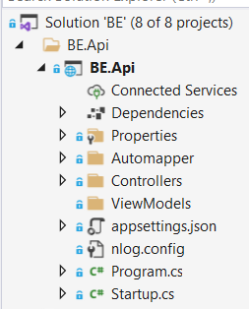

Fig. 1 - BE.Api

This project consists of the Startup.cs file and the Auth, Login, Products and ShoppingCart Controllers.

**Auth controller** - This controller serves as a way of adding a new user to the application.

**Products controller** - This controller is used to retrieve a list of products from the sql server. This list is then displayed on the client web page.

**Login controller** – allows a user to log into the application. The name, surname, token and user id fields are stored in localstorage. Please note that the password is hashed before saving to the database (Auth controller)

Please note that the application uses the CQRS pattern by implementing the MediatR library. This allows the queries to be separate from the commands. We have greater control over enhancing the performance of the application if the operations are divided. The specific service is injected in the query and command handler. See project 3 for dependency injection.

### Project 3. BE.Contracts

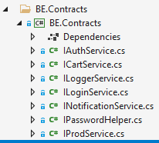

Fig 2. BE.Contracts

Four contracts are used in this project.

1. IOrderService is implemented as a service to perform the query operations. See the CE.Service project.
2. IProdService is implemented as a service to query and update products.
3. ILoggerService is used to implement the NLog logger package.

These interfaces are injected through dependency injection and makes it easier to perform testing. Implementation can be easily swopped out just by defining another concrete implementation in the DI container.

### Project 3 - BE.IoC

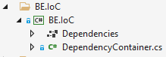

Fig 3. BE.IoC

The Di project registers all the interfaces for dependency injection. This function is normally done inside the Startup.cs class but externalizing this into a separate project, it keeps the Startup.cs cleaner.

### Project 4 - BE.Services

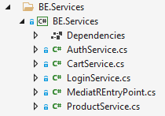

Fig 4. BE.Service

The service project is used to separate the different functions into separate logical components. The service classes implement the corresponding interfaces in CE.Contracts project which is then injected into the controllers.

### Project 5 - BE.Test

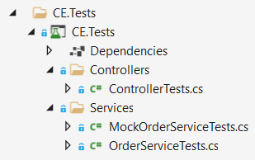

Fig 5. BE.Test

The last project is an Xunit test project for running unit tests. The application is developed using a TDD approach.

### Project 6 – BE.Infrastructure

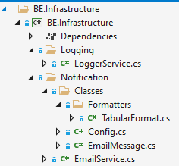

### Project 7 – BE.Common

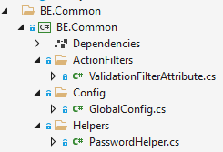

BE.UI

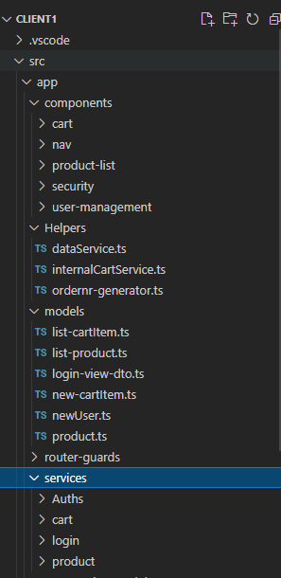

Fig 6. Angular client project

As mentioned, the frontend is done in Angular 12. No specific version 12 commands were used so this should work in earlier versions of angular.

The Fig 6 shows the logical structure of the frontend –

1. Components: This houses the different components used in the project.
2. Services: there are two services in the Services folder that communicates with the CE.Api project by sending data in the form of parameters.
3. Models: contains the entities used in the project.

### Login

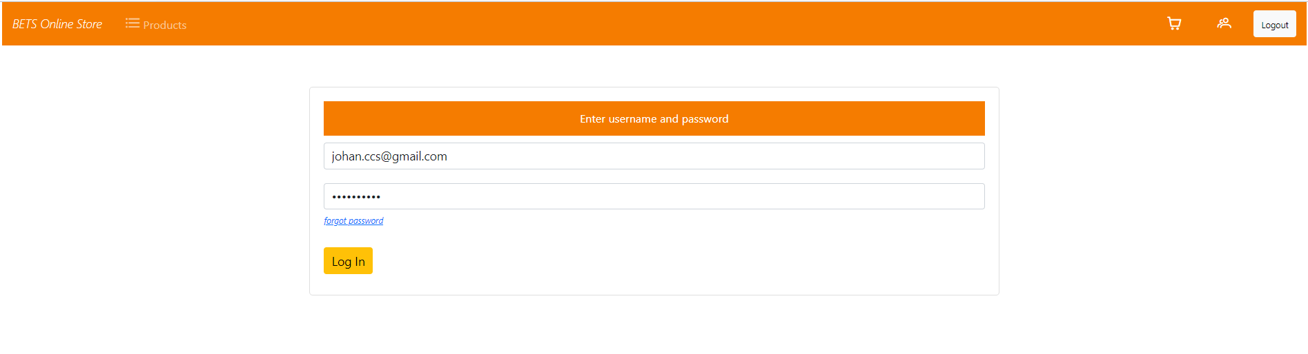

Fig 7. Orders in Progress

Fig 7 shows the list of in progress orders. Clicking on the ‘Orders In Progress’ hyperlink near the top left corner, a call to the orders service is made. This service will in turn contact the backend service which will make an api call to the public endpoint. Data is then passed all the way to the client device where it is displayed. Communication is asynchronous.

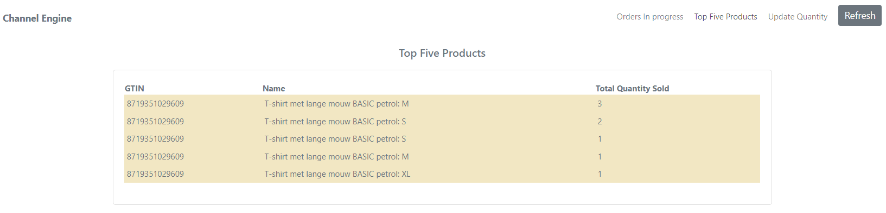

Fig 8. Top Five products

By clicking on the Top Five Products link, the same communication pattern is followed as in Fig 9 to display a list of the top five products being sold.

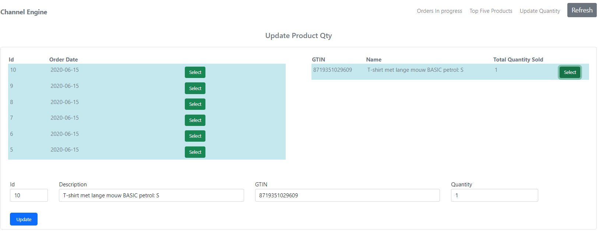

Fig 9.

Fig 11 displays the stock update function. Click on the Update quantity. The list to the left is displayed. By clicking on any of the ‘Select’ buttons – the product detail is displayed in the detail table. Finally clicking on the right line will populate the text boxes. Change the quantity field and click on the ‘Update’ button. This will make post request to the backend server to update the right stock count.

Using Angular allows for dependency injection on the client side as well as an mvc dependency design patter to logically divide the logic into separate modules. The use if services allow for the reuse of components.

Console Output

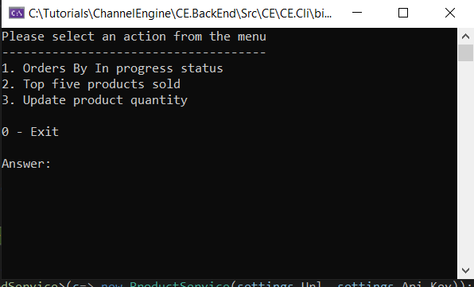

Fig 10. Application menu

Orders in progress

## 

Fig 11. Orders in progress

Fig 11 shows the output of all the orders with a status of IN_PROGRESS. In the console application, I used the injected IOrderService interface to show the use of a different pattern. The logic is still reused from the Api implementation.

Two new classes (DisplayFormattedData.cs and DisplayFormattedProductData.cs) are added to abstract the display logic away from the Runtime class.

Top five Products

## 

Fig 12. Top Five products

Orders Listing activity diagram

Fig 13. Get orders activity diagram

## Conclusion

The construction of the solution is hopefully done in a way that supports loose coupling and high cohesion.

1. Class, method and variable names are given meaningful values. The only time where x is used as variable is as a loop counter variable.
2. The controllers do not contain any logic. Filters can be used to remove redundant code such as try catch.
3. Fields are declared with a leading _ to indicate the role it plays and can be found at the top of each class.
4. Any injected dependency (services) is declared as read-only to keep it immutable.
5. Dividing the solution into separate projects, make the application more testable and maintainable.
6. Please note that all requests are handled asynchronously.
7. The solution is based on TDD.

To get the solution running:

1. Start the api solution. The default url is <http://localhost:5000> and <https://localhost:5001> for https.
2. After opening the angular solution – run the npm install command. This will install all the dependencies needed.
3. Run the front end with ng serve. The default url is <http://localhost:4200>.
4. Testing can also be performed with the use of swagger. Go to url <https://localhost:5001/swagger/index.html>
5. Alternatively – import the the swagger.json (included) into postman. This will setup all the existing endpoints in postman.